TASK ON JENKINS-02.

1) Configure 2 slave machines in the Jenkins master.
- Creating 2 slave machines in the Jenkins master.
- Jenkins Master (EC2)
- Slave 1 → 172.31.18.55
- Slave 2 → 172.31.19.36
Connection → SSH
STEP 1: Setup Jenkins Master

Run on MASTER EC2:
sudo dnf install java-17-amazon-corretto -y
sudo wget -O /etc/yum.repos.d/jenkins.repo https://pkg.jenkins.io/redhat-stable/jenkins.repo
sudo rpm --import https://pkg.jenkins.io/redhat-stable/jenkins.io-2023.key
sudo dnf install jenkins -y
sudo systemctl enable jenkins
sudo systemctl start jenkins
Open:
http://<MASTER-IP>:8080

STEP 2: Prepare Slave Machines (BOTH)
Run on Slave 1 & Slave 2
sudo dnf install java-17-amazon-corretto -y
Verify:
java -version
STEP 3: Setup SSH (CRITICAL STEP)
🔹 On MASTER
ssh-keygen
Press Enter 3 times

🔹 Copy public key
cat ~/.ssh/id_rsa.pub
Copy full key

🔹 On SLAVE 1
mkdir -p ~/.ssh
nano ~/.ssh/authorized_keys
Paste key → Save
chmod 700 ~/.ssh
chmod 600 ~/.ssh/authorized_keys

🔹 Repeat for SLAVE 2

TEST (from MASTER only)
ssh ec2-user@172.31.18.55
ssh ec2-user@172.31.19.36
STEP 4: Add Credentials in Jenkins
Go:
Manage Jenkins → Credentials → Global → Add Credentials
Fill:
- Kind: SSH Username with private key
- Username: ec2-user
- Private Key: Enter directly
Paste:
cat ~/.ssh/id_rsa
- ID: ec2-key
Click Add

STEP 5: Add Slave 1 Node
Go:
Manage Jenkins → Nodes → New Node
Fill:
- Name: slave-1
- Type: Permanent Agent

Configuration
- Remote root:
/home/ec2-user
- Label:
slave1
- Usage:
Use this node as much as possible
- Launch method:
Launch agents via SSH
- Host:
172.31.18.55
- Credentials:
ec2-key
- Host Key Verification:
Non verifying
Save

▶ Launch Agent
Click:
slave-1 → Launch agent
Status:
Online ✅

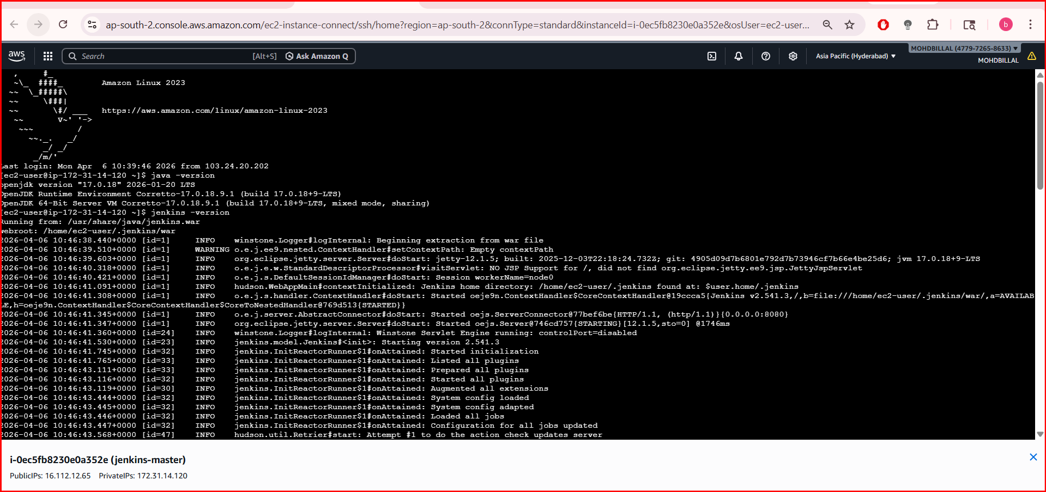
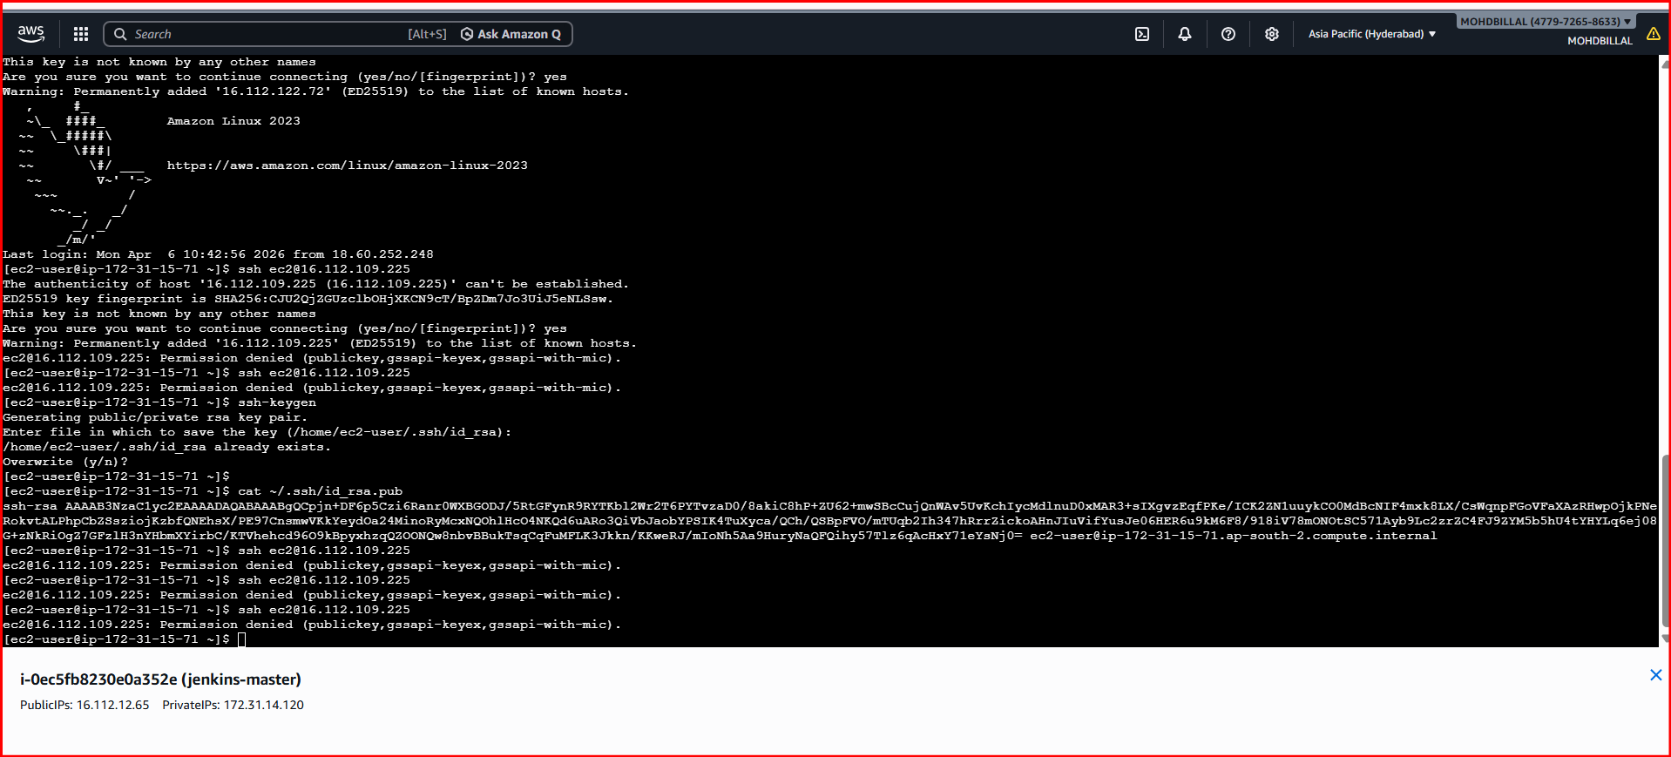
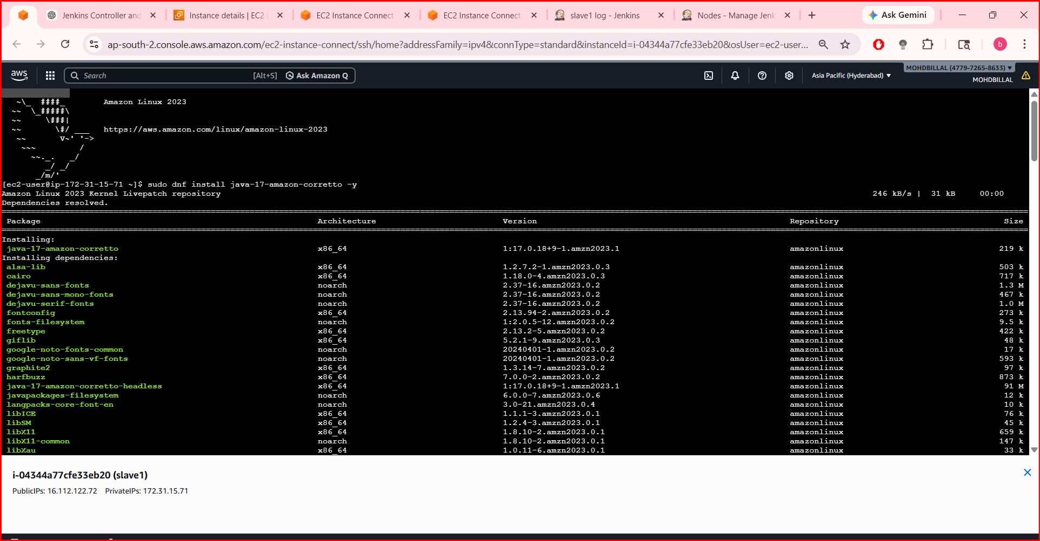
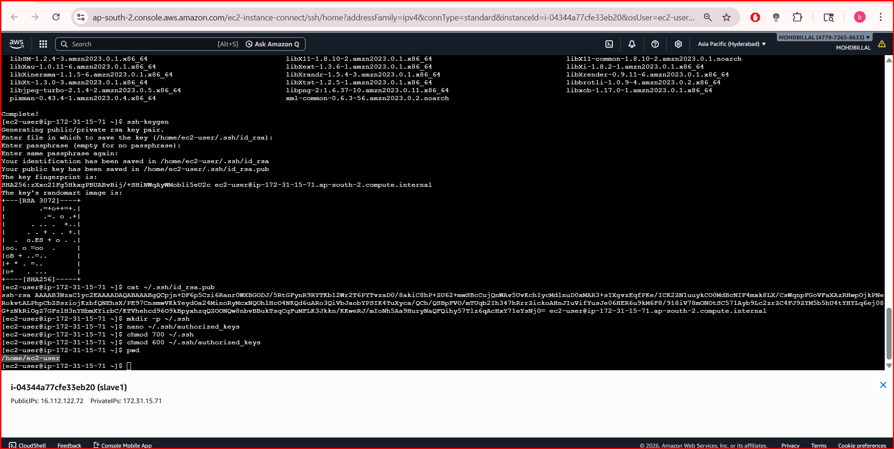
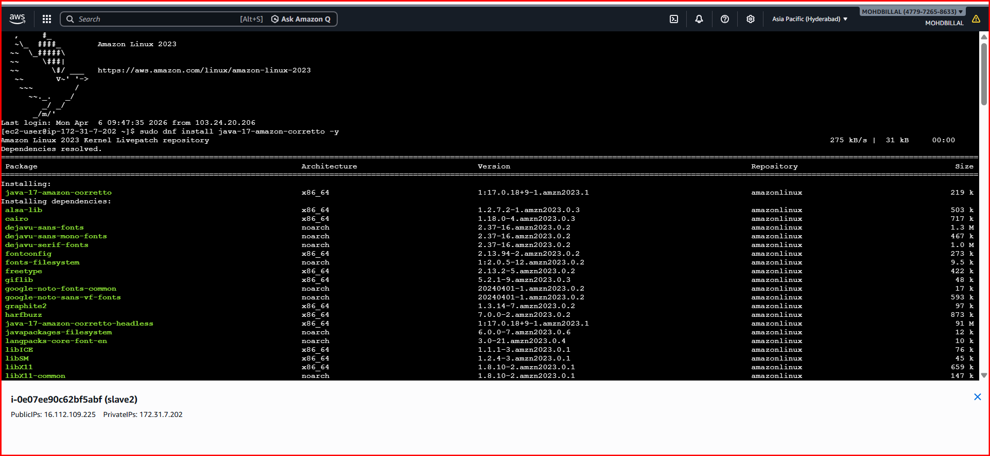
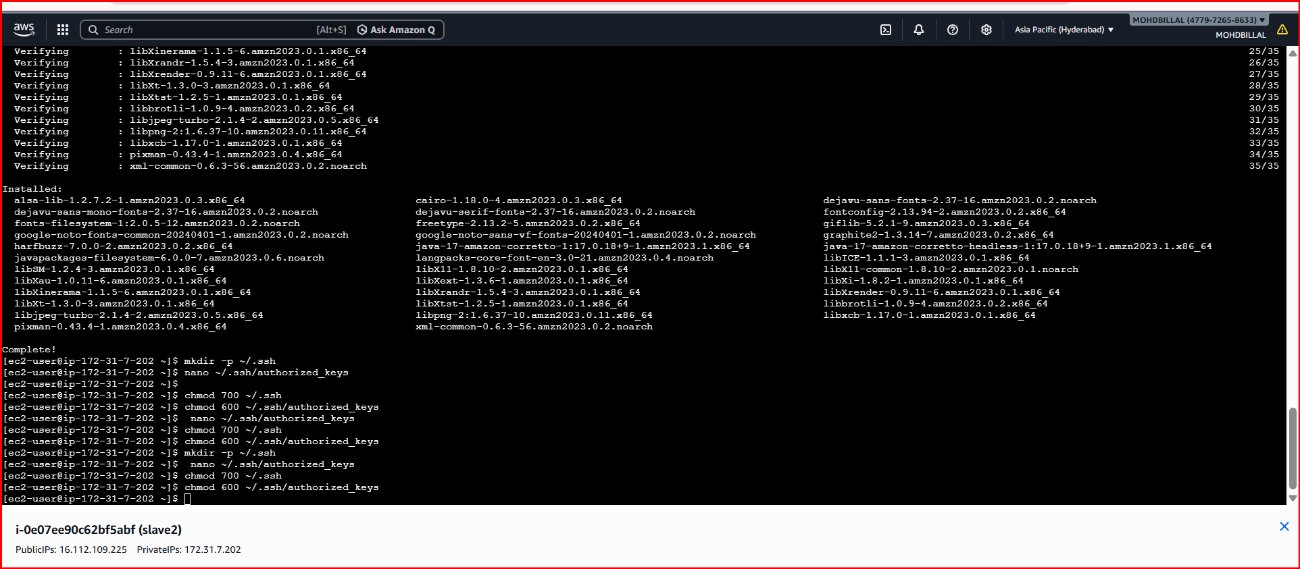
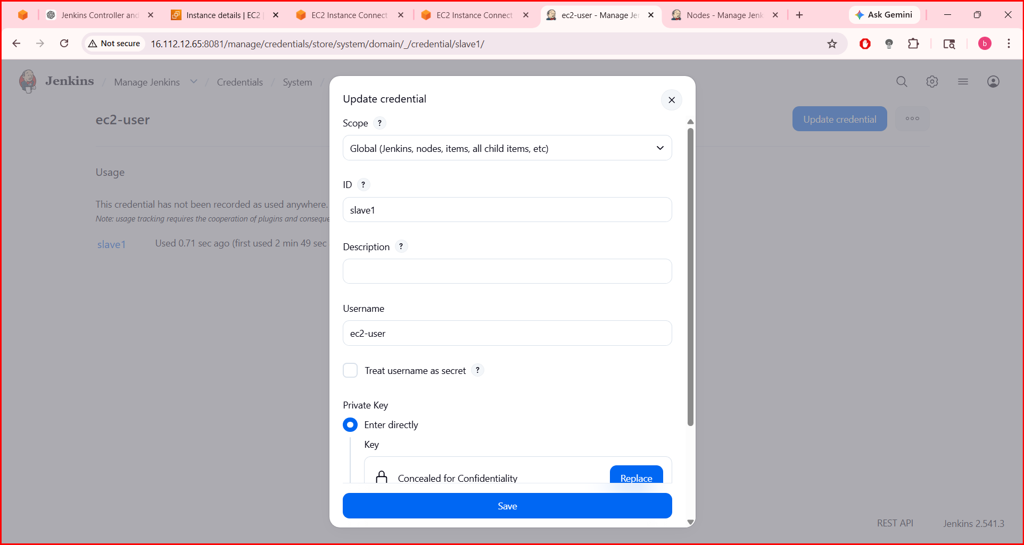
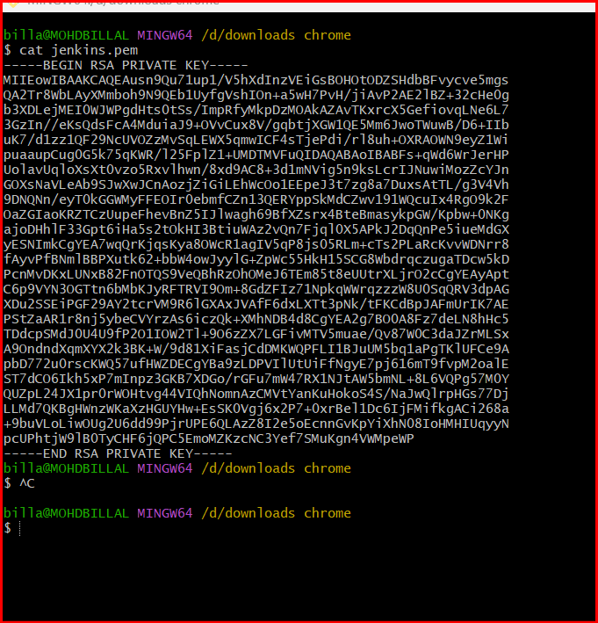
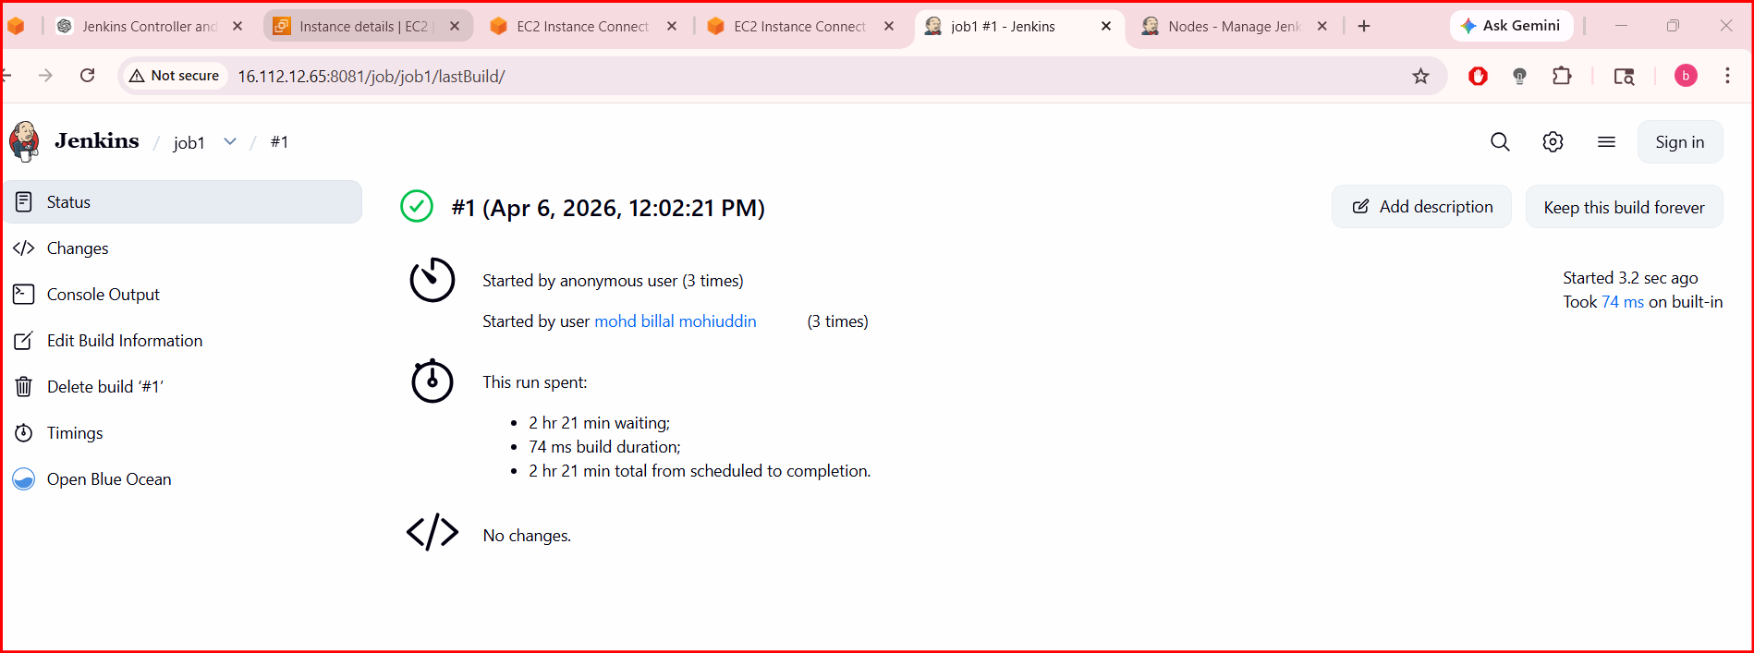

2 Configure Webhooks to the Jenkins job. (GitHub)

GitHub → Repo → Settings → Webhooks
Payload URL:
http://<EC2-IP>:8080/github-webhook/
✔ Content type: application/json
✔ Event: Push
In Jenkins:
✔ GitHub hook trigger for GITScm polling
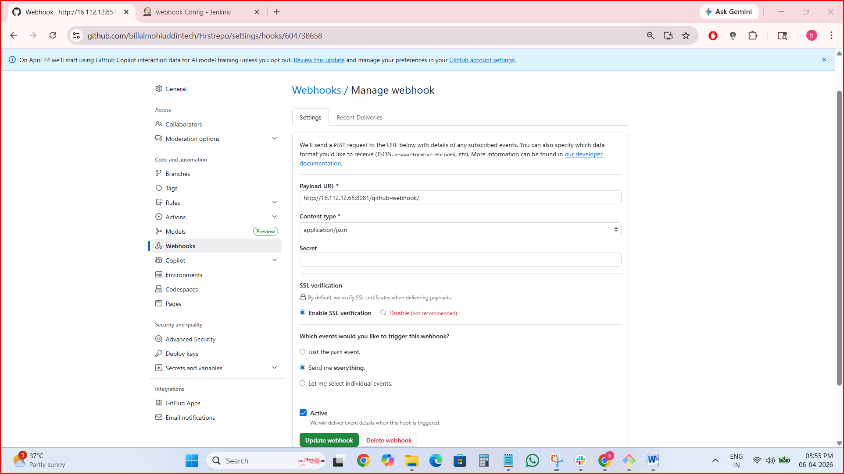
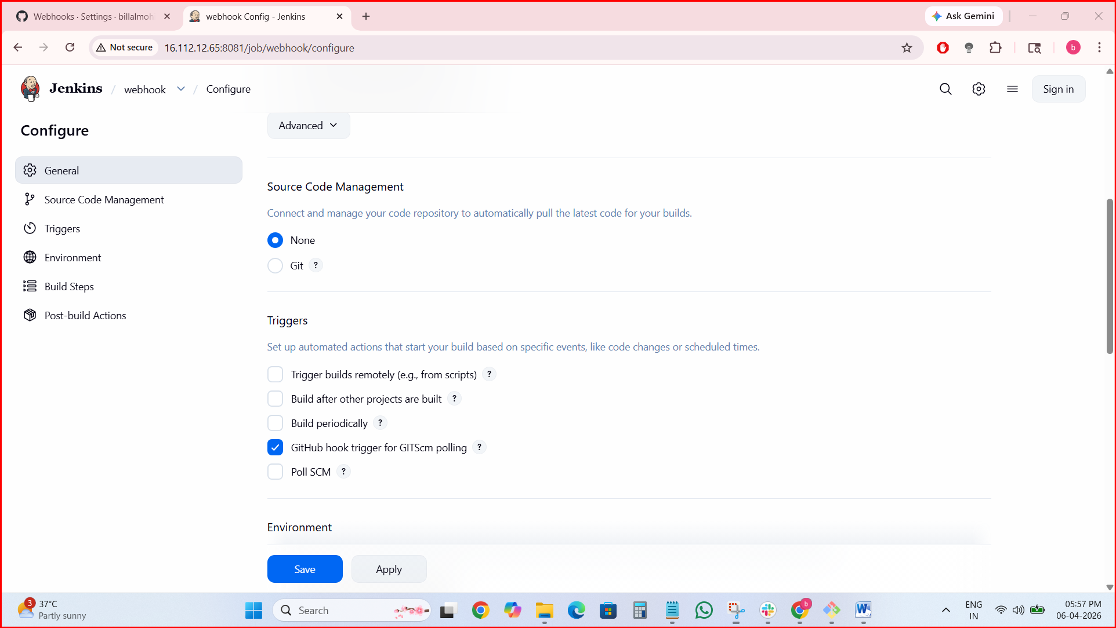
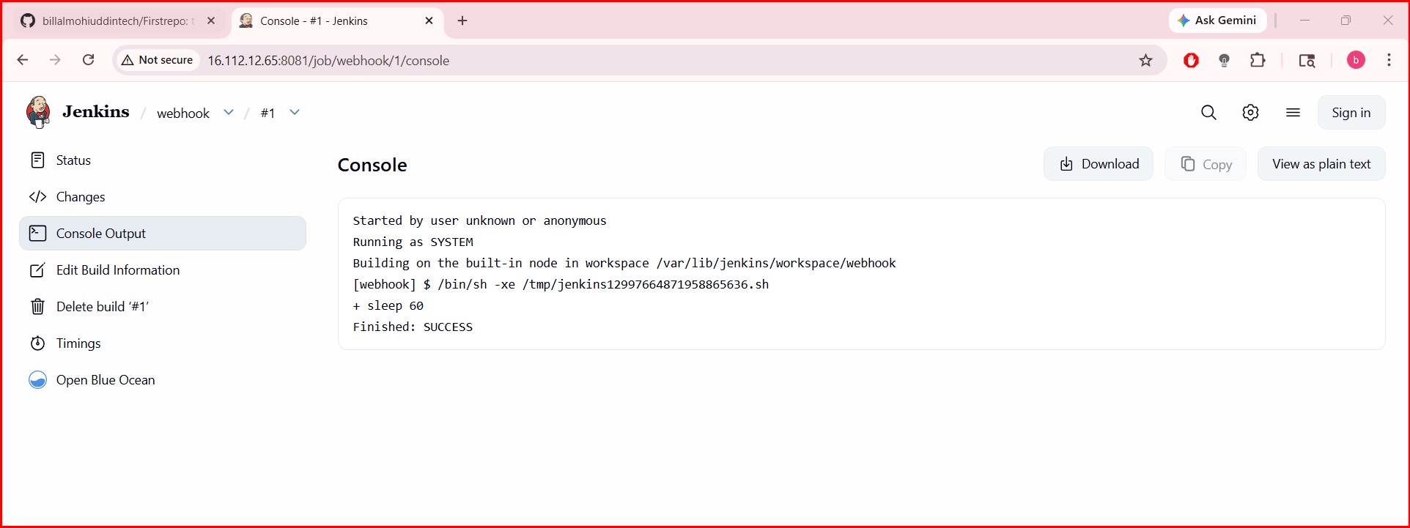

3)Configure Poll SCM and Build Periodically options in the Jenkins job.

Step 1: Prepare Jenkins

1. Install Required Plugin
Go to:
Manage Jenkins → Plugins → Available Plugins
Install:
- Git Plugin
- GitHub Integration Plugin

2. Enable Webhook Trigger in Job
Go to your Jenkins job:
Job → Configure → Build Triggers
✅ Select:
GitHub hook trigger for GITScm polling

🔹 Step 2: Get Jenkins Webhook URL
Your webhook URL will be:
http://<JENKINS_URL>/github-webhook/

Example:
http://13.233.100.10:8081/github-webhook/
⚠️ Important:
- Must be publicly accessible
- Port (like 8081) must be open in firewall/security group

🔹 Step 3: Configure Webhook in GitHub
Go to your repository on GitHub:

Navigate:
Repository → Settings → Webhooks → Add webhook

Fill details:
- Payload URL →
http://<JENKINS_URL>/github-webhook/
- Content type →
application/json
- Events →
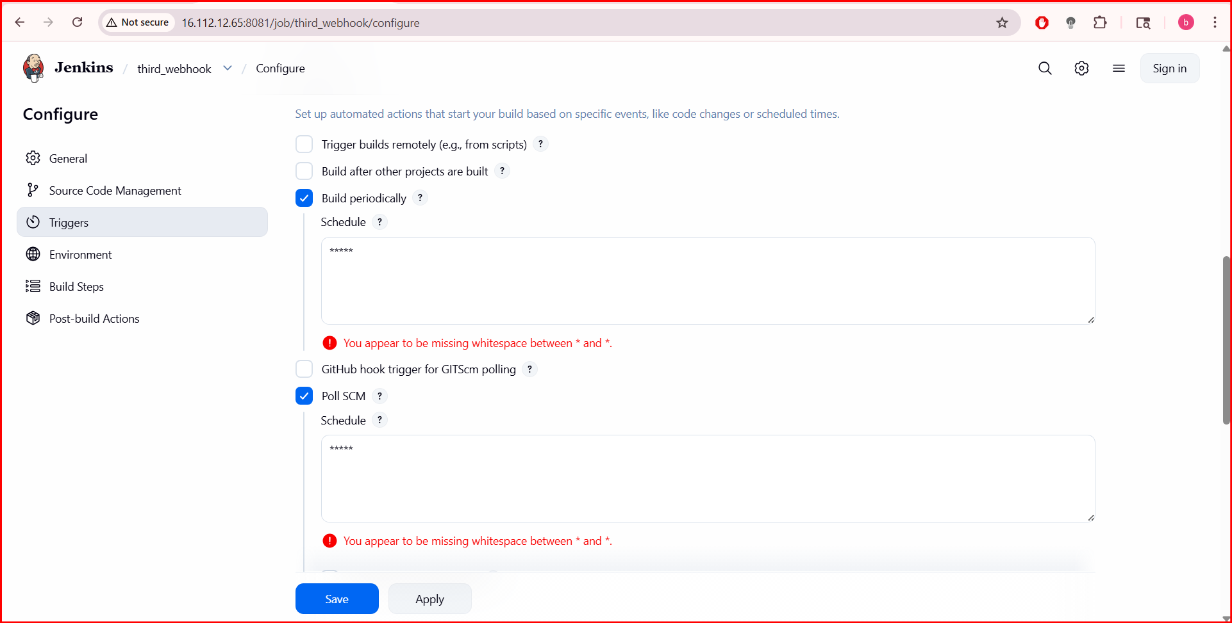

4. Take a backup of the Jenkins server using a bash-script.
jenkins data is stored in:
/var/lib/Jenkins

✅ Step 1: Create Backup Directory
sudo mkdir -p /backup/jenkins

✅ Step 2: Create Bash Script
Create a file:
sudo vi jenkins_backup.sh

✅ Step 3: Add Script Code
Paste this:
#!/bin/bash
# Variables
JENKINS_HOME="/var/lib/jenkins"
BACKUP_DIR="/backup/jenkins"
DATE=$(date +%F-%H-%M)
# Stop Jenkins
echo "Stopping Jenkins..."
sudo systemctl stop jenkins
# Create backup
echo "Taking backup..."
tar -czvf $BACKUP_DIR/jenkins_backup_$DATE.tar.gz $JENKINS_HOME
# Start Jenkins
echo "Starting Jenkins..."
sudo systemctl start jenkins
echo "Backup completed successfully!"

✅ Step 4: Give Execute Permission
chmod +x jenkins_backup.sh

✅ Step 5: Run the Script
./jenkins_backup.sh

✅ Step 6: Verify Backup
ls -lh /backup/jenkins
You should see:
jenkins_backup_2026-04-06-12-30.tar.gz
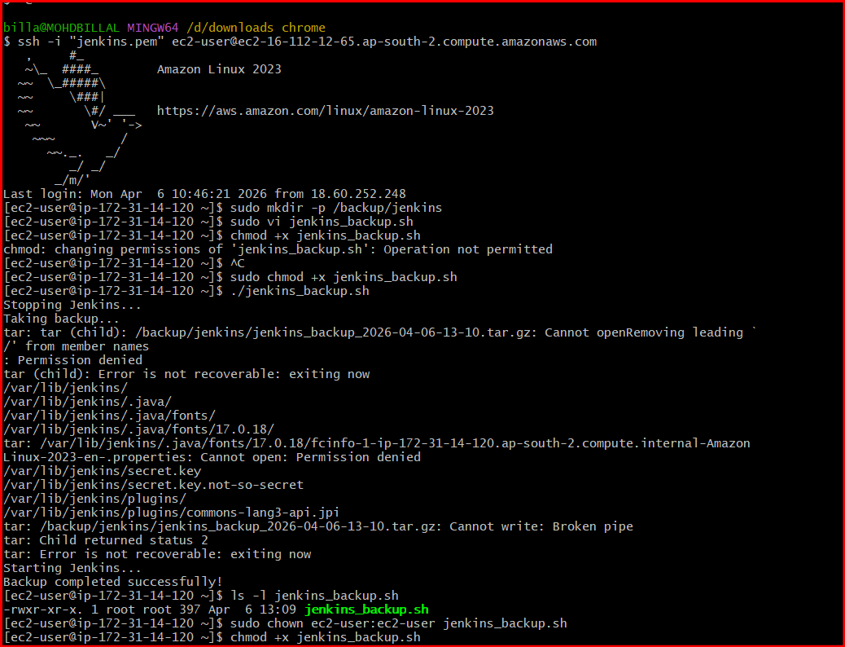
5) Take a backup of Jenkins using the ThinBackup plugin.

Step 1: Install ThinBackup Plugin
- Go to:
Manage Jenkins → Plugins → Available Plugins
- Search:
ThinBackup
- Install:
ThinBackup Plugin
- Restart Jenkins

✅ Step 2: Configure Backup Settings
- Go to:
Manage Jenkins → ThinBackup
- Click:
Settings

🔹 Configure these fields:

Backup Directory
/backup/jenkins
👉 Create it if not exists:
sudo mkdir -p /backup/jenkins
sudo chmod 777 /backup/jenkins

Step 3: Take Backup Manually
- Go to:
Manage Jenkins → ThinBackup
- Click:
Backup Now
👉 Backup will start immediately

✅ Step 4: Verify Backup
Check directory:
ls -lh /backup/jenkins
You will see files like:
FULL-2026-04-06_12-30.zip

✅ Step 5: Restore Backup (Important)
- Go to:
Manage Jenkins → ThinBackup
- Click:
Restore
- Select backup file
- Restart Jenkins
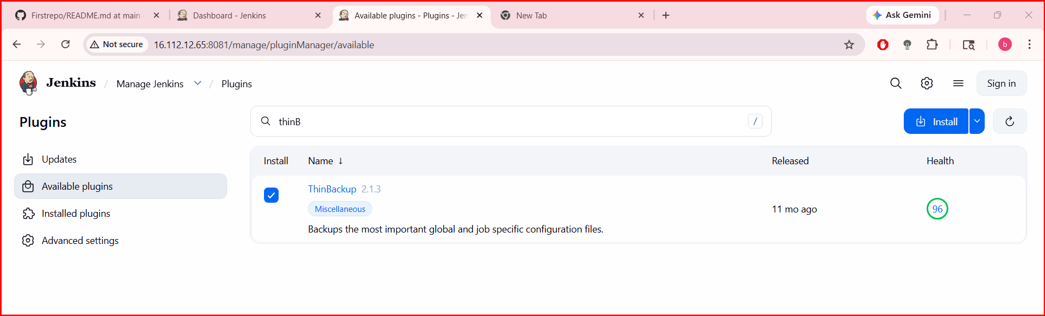
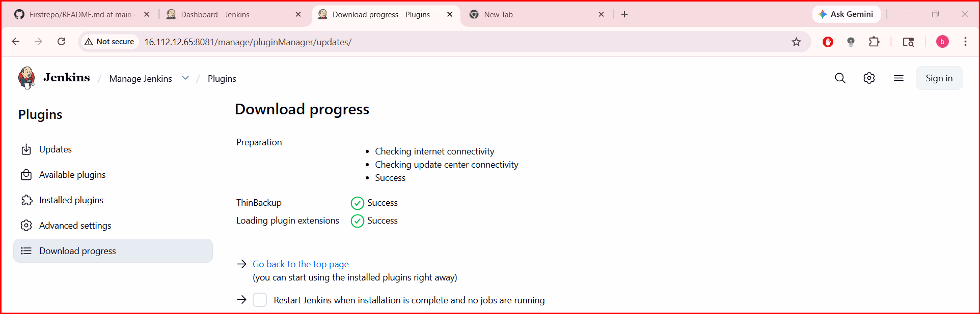

Set up a new Jenkins server and restore the backup taken in task 4.
Restore Jenkins Backup on New Server
STEP 1: Launch New Server
Create new VM (AWS EC2 / local / VM)
Minimum:
- OS: Amazon Linux / Ubuntu
- RAM: 2GB+
- Open ports: 8080 (Jenkins)

STEP 2: Install Java (Jenkins dependency)
For Amazon Linux:
sudo dnf install java-17-amazon-corretto -y
Check:
java -version
STEP 3: Install Jenkins
Amazon Linux:
sudo wget -O /etc/yum.repos.d/jenkins.repo https://pkg.jenkins.io/redhat-stable/jenkins.repo
sudo rpm --import https://pkg.jenkins.io/redhat-stable/jenkins.io-2023.key
sudo dnf install jenkins -y
STEP 4: Start Jenkins
sudo systemctl daemon-reexec
sudo systemctl enable jenkins
sudo systemctl start jenkins
Check:
sudo systemctl status Jenkins
STEP 5: Unlock Jenkins (First Time)
sudo cat /var/lib/jenkins/secrets/initialAdminPassword
Open browser:
http://<your-server-ip>:8080
Paste password
Install suggested plugins (temporary step)

Step 1: Start SSH Agent
eval $(ssh-agent)

Step 2: Add your key
ssh-add jenkins.pem
Expected output:
Identity added: jenkins.pem

Step 3: Now connect WITH agent forwarding
ssh -A ec2-user@3.90.201.74

If still fails (backup safe command)
Use both agent + key:
ssh -A -i jenkins.pem ec2-user@3.90.201.74
This ALWAYS works

After login (inside OLD EC2)
Run:
scp /opt/jenkins-backup/jenkins-backup-2026-03-25-06-20.tar.gz ec2-user@18.208.131.63:/home/ec2-user/
IMPORTANT CHECK (don’t skip)
Make sure NEW EC2 allows OLD EC2:
Security Group of NEW EC2:
SSH (22)
Source: 3.90.201.74/32

NOW FINAL STEP: RESTORE JENKINS
Let’s finish the mission.

STEP 1: Login to NEW EC2
From your laptop:
ssh -i jenkins.pem ec2-user@18.208.131.63

STEP 2: Verify file
ls /home/ec2-user
You should see:
jenkins-backup-2026-03-25-06-20.tar.gz

STEP 3: Extract backup
tar -xvzf jenkins-backup-2026-03-25-06-20.tar.gz

STEP 4: Stop Jenkins
sudo systemctl stop jenkins

STEP 5: Replace Jenkins Home
sudo mv /var/lib/jenkins /var/lib/jenkins-old
sudo cp -r backup/* /var/lib/jenkins/
(if folder name is different, use that)
ls var/lib/
sudo cp -r var/lib/jenkins /var/lib/

STEP 6: Fix permissions
sudo chown -R jenkins:jenkins /var/lib/jenkins

STEP 7: Start Jenkins
sudo systemctl start jenkins

FINAL CHECK
Open in browser:
http://18.208.131.63:8080
Case 1: Jenkins opens normally
DONE — everything restored successfully
Just login with:
your old username & password

Case 2: Login page appears but you forgot password
No problem 😏 fix it:
Reset password (quick method)
sudo vi /var/lib/jenkins/config.xml
Find:
<useSecurity>true</useSecurity>
Change to:
<useSecurity>false</useSecurity>

Then restart:
sudo systemctl restart jenkins
Now open Jenkins:
- It will open without login
- Create new user:
- Manage Jenkins → Security → Create user

- Re-enable security:
- Change back:
- <useSecurity>true</useSecurity>
- Restart again
